VOLUNTEER SIGNUP & HOURS TRACKER
@CREATIVITY THINK (9483175986/7019689991)

ABSTRACT:
The Volunteer Signup & Hours Tracker is a web-based application designed to help organizations efficiently manage volunteer activities, event participation, and service hour tracking. The platform enables volunteers to browse opportunities, register for events, log their hours, and view activity dashboards. Administrators can manage opportunities, monitor signups, validate logged hours, and analyze volunteer engagement through interactive analytics. Built using Django and Django Rest Framework on the backend, and React with Redux and recharts on the frontend, the system provides a scalable, user-friendly, and transparent volunteering management solution..

INTRODUCTION OF THE PROJECT:
Many nonprofits and community groups struggle with managing volunteers due to manual signups, inconsistent hour tracking, and limited communication regarding upcoming events. These traditional systems lack efficiency, transparency, and real-time coordination. The Volunteer Signup & Hours Tracker offers a centralized platform for organizing volunteer opportunities, managing participation, and recording service hours accurately. Through a modern web interface, the system ensures seamless interaction between volunteers and administrators while improving engagement visibility and operational management..

PROJECT OBJECTIVES:

• Provide a centralized system for volunteer signups and activity tracking
• Allow volunteers to browse opportunities and register for events
• Enable users to log their service hours digitally
• Provide an event calendar for better planning and coordination
• Offer interactive dashboards to review volunteer performance
• Enable administrators to moderate hours and manage opportunities
• Reduce manual paperwork and increase operational transparency
• Support data-driven decision-making with integrated analytics

PROBLEM OF THE STATEMENT:
Organizations relying on manual signup sheets and physical hour logs face issues such as inaccurate data, misplaced records, miscommunication, and poor visibility into volunteer participation. Volunteers may forget to record hours or fail to receive timely updates on upcoming opportunities. The Volunteer Signup & Hours Tracker addresses these challenges through a digital, structured, and transparent system that automates volunteer coordination, hour tracking, and event management, ensuring reliability and improved volunteer engagement..

MOTIVATION OF THE PROJECT:
• To replace manual hour-tracking and signup processes
• To increase transparency and efficiency in volunteer management
• To provide volunteers with real-time access to available events
• To offer administrators a comprehensive dashboard for oversight
• To support NGOs and organizations with better engagement tools
• To streamline hour verification and reporting
• To encourage volunteer participation through a modern digital platform

BLOCK DAIGRAM OF PROJECT:

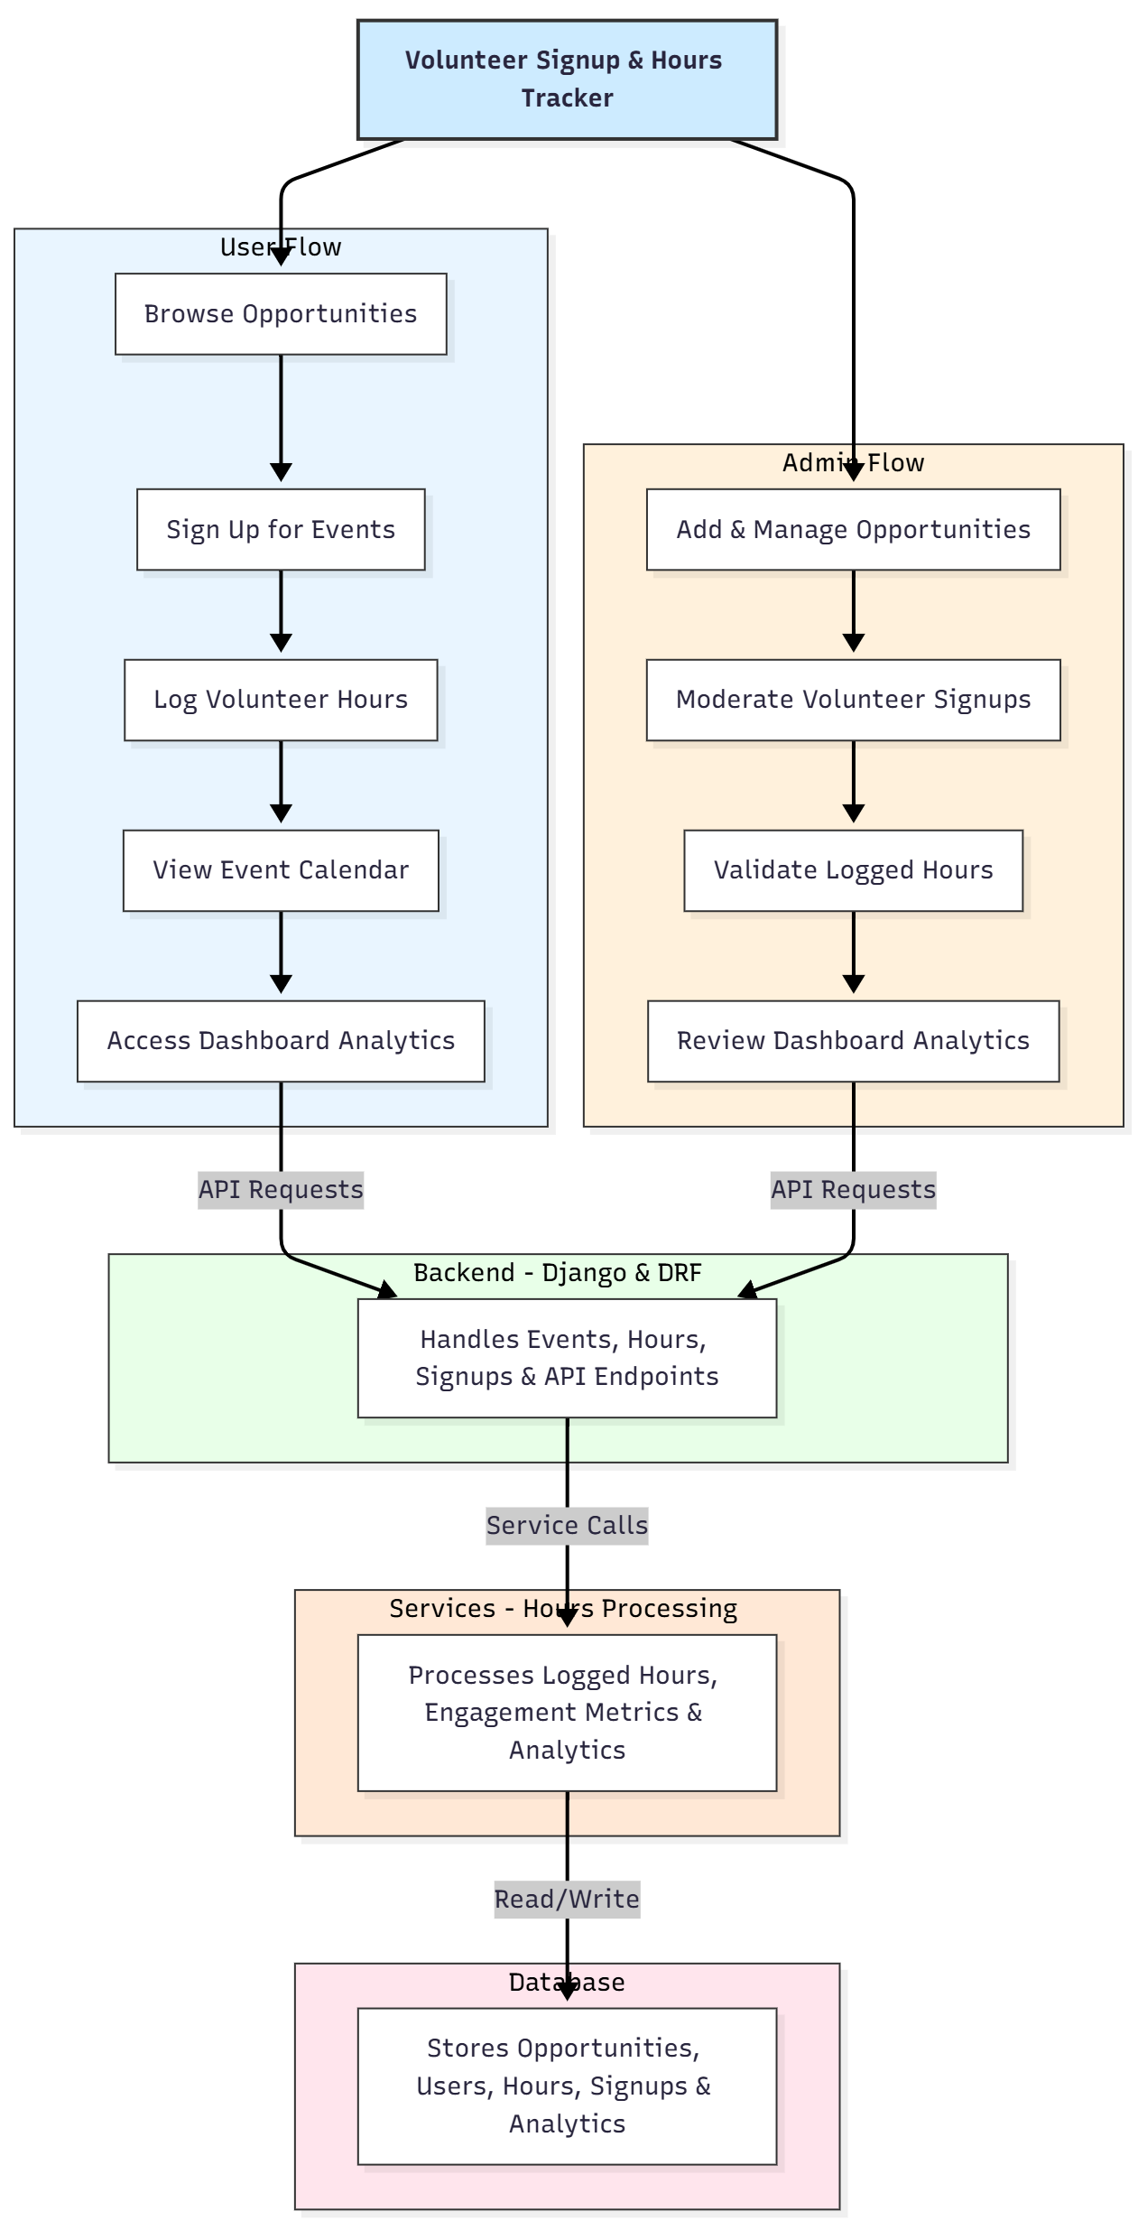

WORKING OF THE PROJECT:
Administrators begin by adding volunteer opportunities and event details to the system. Volunteers can browse available openings, sign up for events, and log their completed service hours. The backend validates event capacities, signup status, and submitted hours before storing data securely. Volunteers can view upcoming events through the integrated calendar, while both volunteers and administrators access performance analytics via dashboards. Administrators review submitted hours, approve or flag entries, and monitor overall participation. All activities are logged in the database to ensure transparency and accurate record-keeping..

SOFTWARE REQUIREMENT:
- Backend:
  - Python 3.x
  - Django
  - Django REST Framework
  - SQLite/PostgreSQL
- Frontend:
  - Node.js and npm
  - React.js
  - Axios
- Development Tools:
  - Visual Studio Code
  - Postman (for testing APIs)
  - Git/GitHub (for version control)
- Server/Deployment (Optional):
  - Gunicorn, Nginx, or Heroku/AWS for hosting

ADVANTAGES OF THE PROJECT:

• Eliminates manual volunteer hour tracking
• Provides clear visibility into upcoming events
• Enables quick and organized volunteer signups
• Enhances transparency with validated hour logs
• Offers real-time insights through dashboards
• Improves communication and volunteer engagement
• Reduces paperwork and human errors
• Scales easily for large nonprofit organizations

APPLICATIONS OF THE PROJECT:
• NGOs and nonprofit organizations
• Community groups
• Social service organizations
• Educational institutions
• Church and community volunteer programs
• Corporate CSR volunteer initiatives

REFERENCES:

- Django REST Framework Documentation — Django Software Foundation. Django Documentation. Available: https://docs.djangoproject.com/
- Django REST Framework. DRF Documentation. Available: https://www.django-rest-framework.org/
- React. React Official Documentation. Available: https://reactjs.org/docs/getting-started.html
- Redux. Redux Documentation. Available: https://redux.js.org/introduction/getting-started
- PostgreSQL Global Development Group. PostgreSQL Documentation. Available: https://www.postgresql.org/docs/
- MySQL. MySQL Reference Manual. Available: https://dev.mysql.com/doc/
- Git. Git Documentation. Available: https://git-scm.com/doc
- Node.js. Node.js Documentation. Available: https://nodejs.org/en/docs/
- Axios. Axios Documentation. Available: https://axios-http.com/docs/intro
- Socket.io Documentation – https://socket.io/docs/

